Did You Know?  The ICG developed Guidelines for Ensuring Fair Competition that we encourage costuming competitions to adopt. We also offer special recognition to international competitions that draw entrants and audiences from outside the host country, and follow the ICG's Guidelines. WorldCon, Costume-Con, and Anime North are currently recognized as ICG international competitions.  The ICG International Costumers’ Gallery and the Pat and Peggy Kennedy Memorial Archives preserve a large collection of photos, videos and costume-related materials from nearly seven-decades of fan costuming.  The Marty Gear Costuming Arts and Sciences Fund provides grants for innovative projects and activities that promote the art and science of costuming, either in a specific locale or the community as a whole. |  |  | More about the ICG  The International Costumers' Guild (ICG) was formed in 1985 to bring both hobbyist and professional costumers from around the world together, and to foster local educational and social costume events.  Our members include historic reenactors, professional, educational and community theatrical costumers, science fiction fans, renaissance festival participants, and all those who are interested in the making, wearing and display of costumes.  Email: info@costume.org  ICG Costume Chat: https://groups.google.com/a/costume.org/g/cos-chat  Facebook Discussion Group: https://www.facebook.com/groups/315077302329938  Website: http://costume.org/ |  |  | Join the International Costumers’ Guild  - http://www.costume.org/

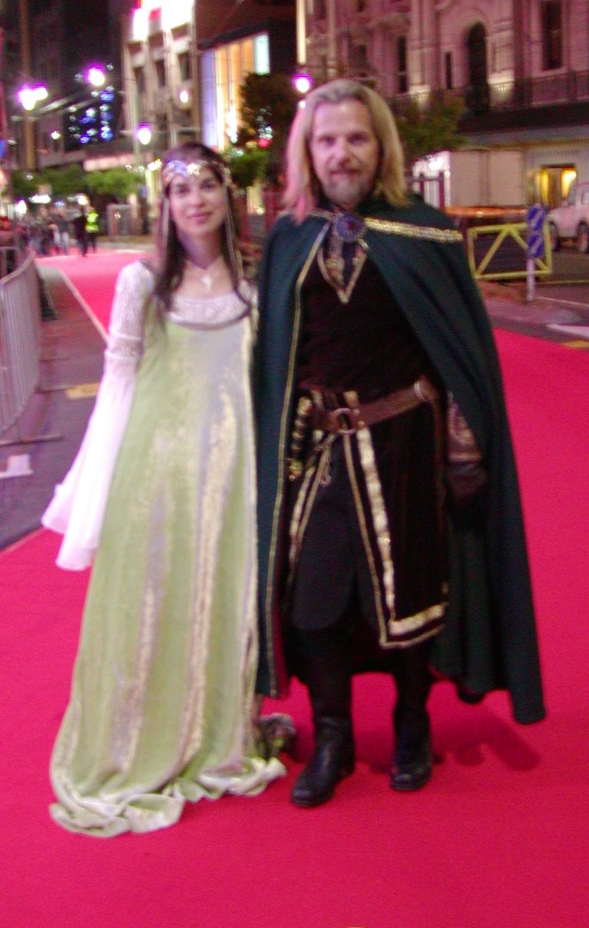  The International Costumers' Guild, Inc., is an affiliation of amateur, hobbyist, and professional costumers dedicated to the promotion and education of costuming as an art form in all its aspects. |  |  | The ICG has over 17 chapters and Special Interest Groups (SIGs). Chapters cover a specific geographical area, enabling members to meet on a regular basis, trading tips, skills, and ideas. Many chapters also produce newsletters, and use social media to share information and exchange ideas.  The ICG provides advice and expertise to the costuming community worldwide!  SIGs enable members anywhere with an interest in some aspect or genre of costuming to pursue their interest and share information.  Our ICG-D Yahoo! Group is open to anyone with an interest in costuming. The group is managed by the ICG, but anyone with an interest in costuming is welcome to join in the discussion. |  |  | 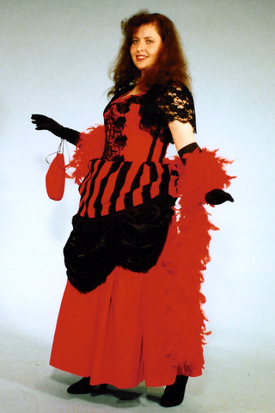  ICG not only offers members a chance to interact internationally, but our local chapters, including an “internet” chapter, provide a social network for discussion, fun events at the local level and a support group for costuming at regional and international conventions.  Find a chapter in your area on our website:  http://www.costume.org/chapters/

